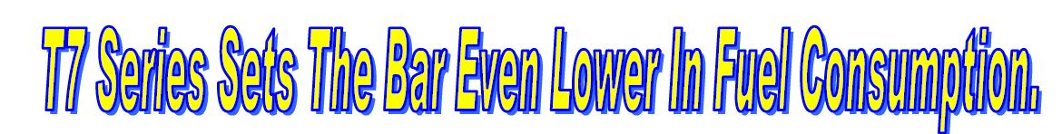

Once again New Holland leads the way with engine & transmission technology that is kind on our environment!

With 259 and 261 g/kWh, the New Holland T7.260 and T7.270, featuring Tier4 compliant SCR technology, achieve best results ever for tractors of their class in the European DLG PowerMix test
No matter the choice of transmission, either Power Command™ (PowerShift) or Auto Command™ (CVT), the new T7 ECOBlue™ Selective Catalytic Reduction technology equipped T7.260 and T7.270 offer the best fuel economy of the 170-230 Hp tractor segment.
ECOBlue™ Selective Catalytic Reduction technology is confirmed as the winning choice to reduce fuel consumption and maximize productivity, while meeting emission regulations.
New Holland, the Clean Energy Leader with an offering of 20 tractor and five combine Tier 4 SCR models available now, brings today the benefits of tomorrow’s technology.

The Deutsche Landwirtschafts-Gesellschaft (DLG) German Society for Agriculture recently published the PowerMix test results for New Holland Tier4A SCR T7.260 Power Command™ and T7.270 Auto Command™, please click on link below, or see attached test results:
o T7.260 o T7.270

The results officially and definitively confirm New Holland's record fuel economy achieved thanks to Fiat Power train Tier 4 ECOBlue™ Selective Catalytic Reduction technology.

Please find attached to this bulletin, the actual DLG PowerMix results for T7.260 Power Command & T7.270 Auto Command. Fuel savings achievable with Selective Catalytic Reduction (SCR) Technology will far outweigh any negatives on having to add AD/ Blue Fluid to New Holland tractors, when compared with Exhaust Gas Recirculation (EGR) as found on John Deere Tier 4a (Stage 3B) tractors.
This technology allows the engine to ‘breathe’ clean air, instead of re-circulated exhaust gases. This means the engine simply does what is designed for: producing the maximum power from a given quantity of fuel.
This, together with all the other features of the acclaimed multi-award winning T7 range, confirms that no matter the customer transmission preference, the best choice is always New Holland.
New Holland Agriculture does have the widest range of machines with Tier4A SCR technology to choose from in the industry: 20 tractor and five combine harvester models.
"The recently published DLG figures fully confirm our clear leadership, both in terms of productivity and fuel economy.”

Summary of the DLG PowerMix tests for 170-230Hp tractor segment:
These actual results have been sourced from the DLG Test Centre Germany, and do carry a lot of weight in the agricultural industry and International equipment magazines such as Profi, quite often use the DLG Centre as a source of their tractor test.

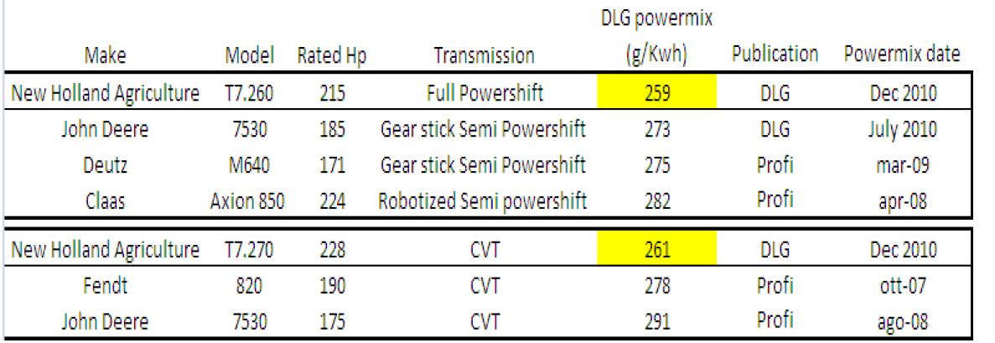

Have a look for yourself at the DLG website:
http://www.dlg.org/tractors.html

